NAME: ARUNMOZHI N
ROLL NO: 241901008
EXPERIMENT 3
RECOVER DELETED FILES USING FORENSICS TOOLS
AIM
To recover deleted files from a storage device using forensic tools and examine the recovered data.
PROCEDURE
- Select a storage device or disk image for the file recovery process.
- Open a suitable forensic recovery tool.
- Select the drive or storage location from which the deleted files need to be recovered.
- Scan the selected storage device for deleted files and folders.
- Wait for the scanning process to complete.
- Examine the list of deleted files identified by the software.
- Select the required files that are available for recovery.
- Choose a separate destination folder to save the recovered files.
- Recover the selected files and verify whether they can be opened successfully.

OBSERVATION
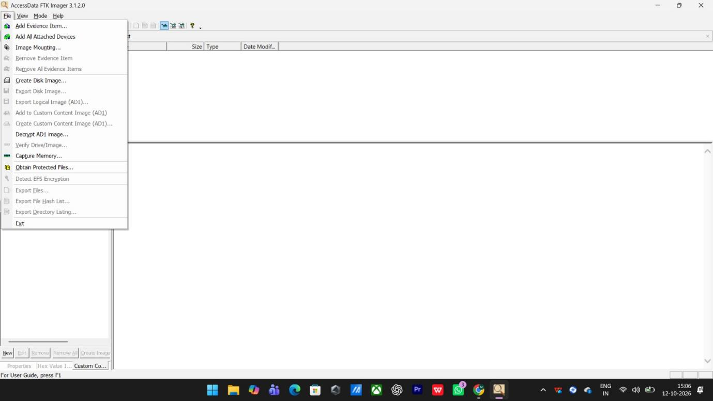

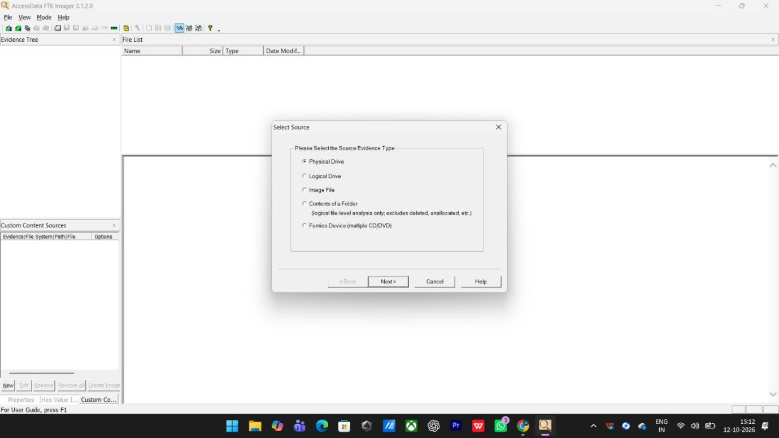

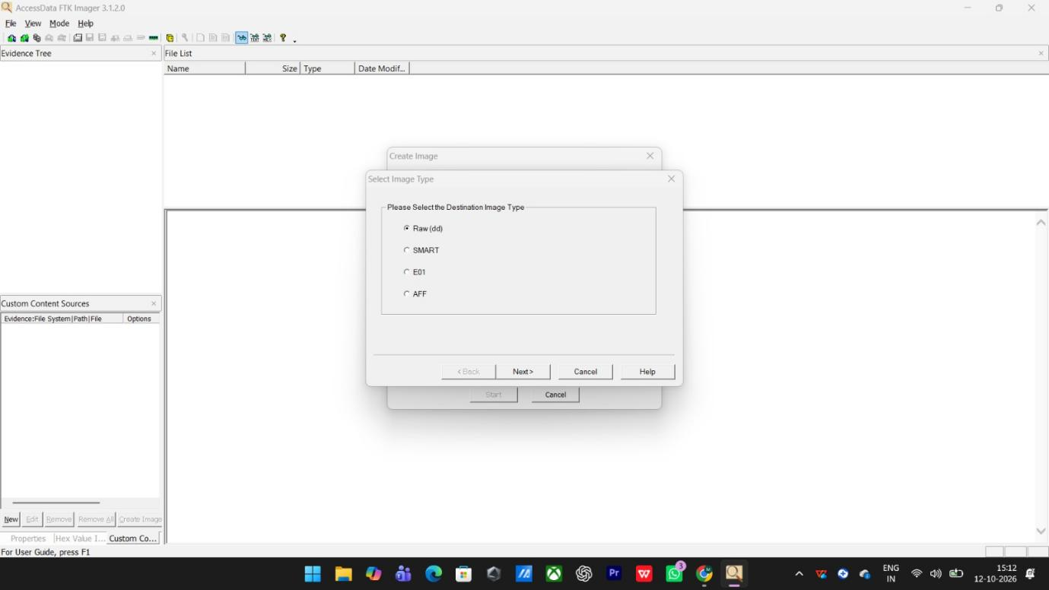

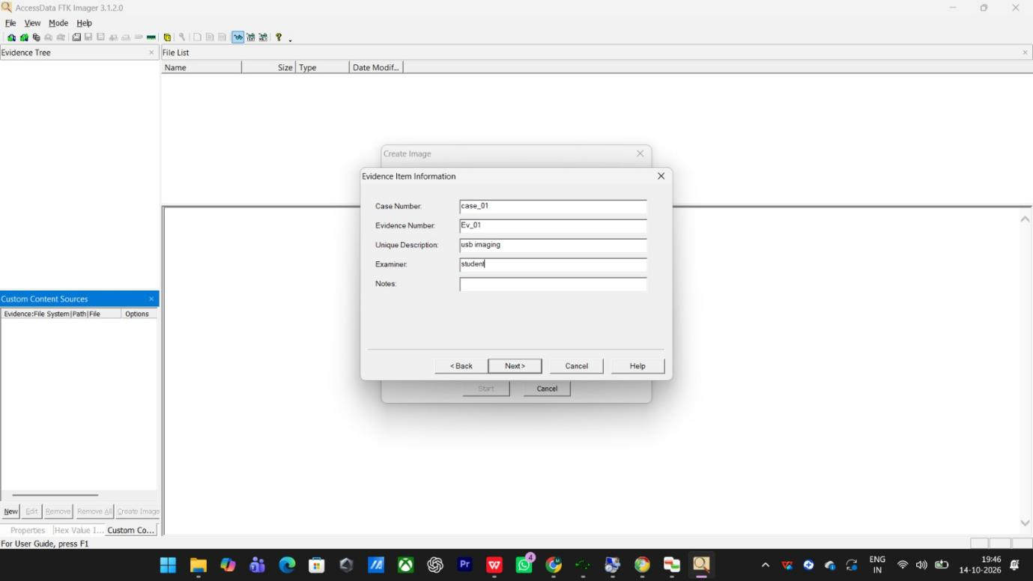

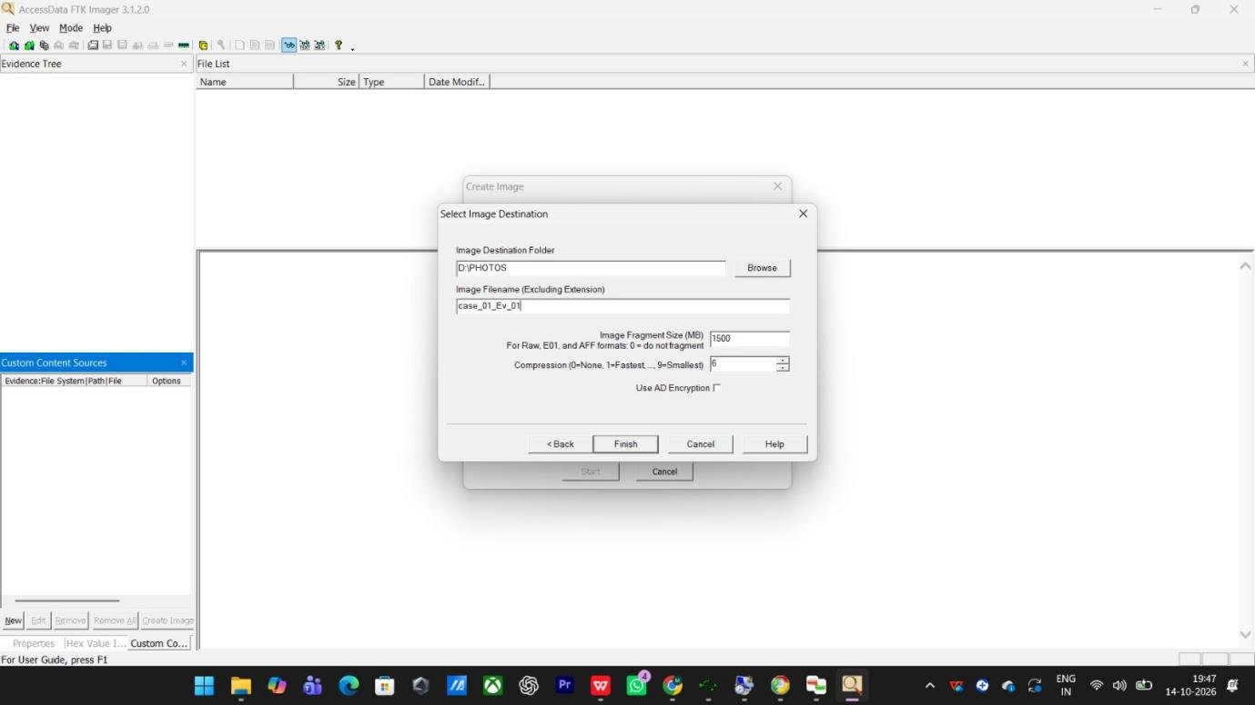

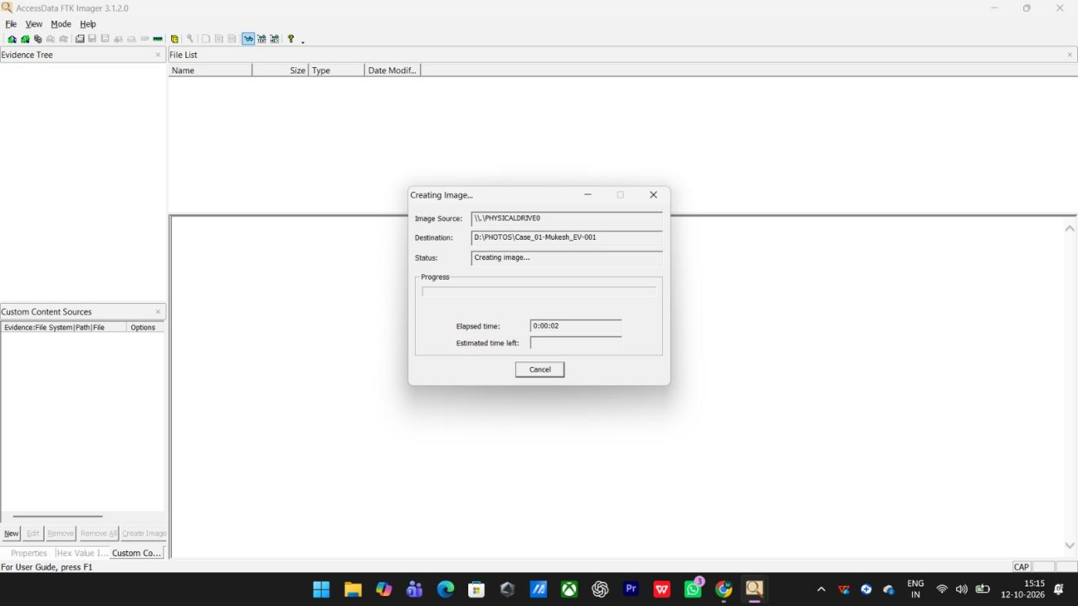

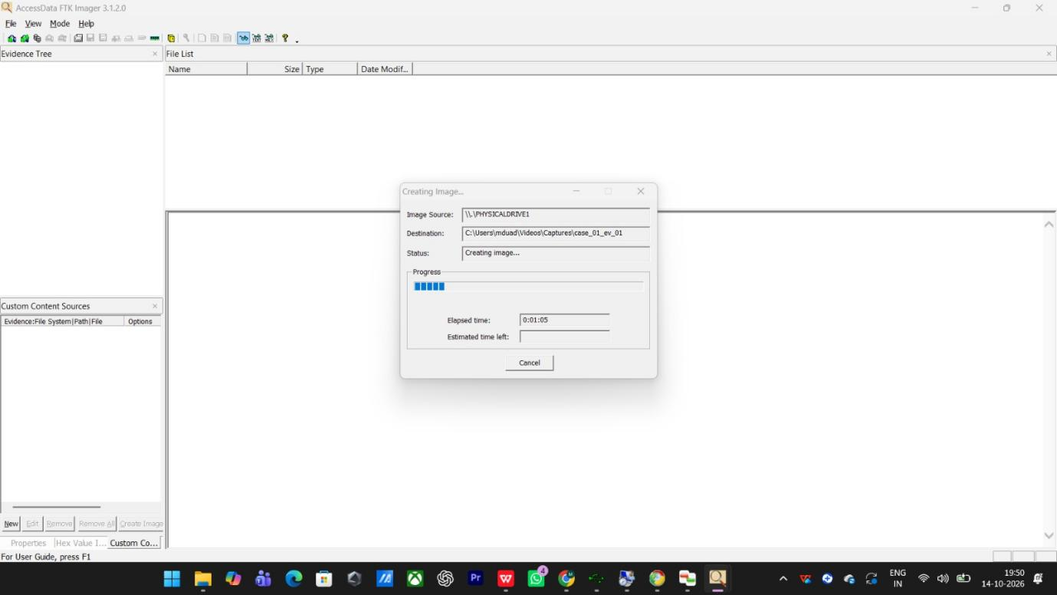

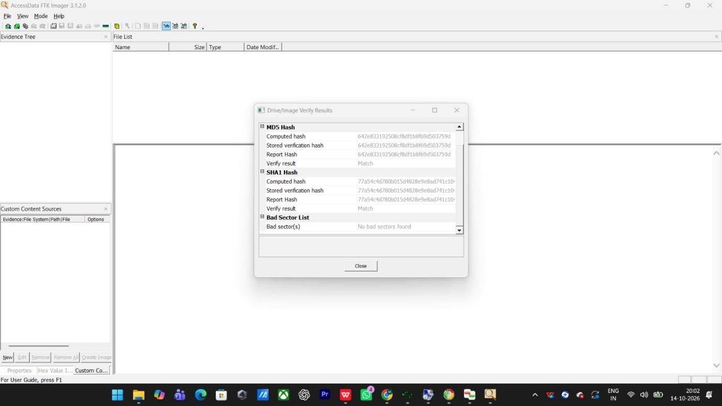

RESULT
Deleted files were searched for and recovered using forensic recovery tools, and the recovered data was examined successfully.

